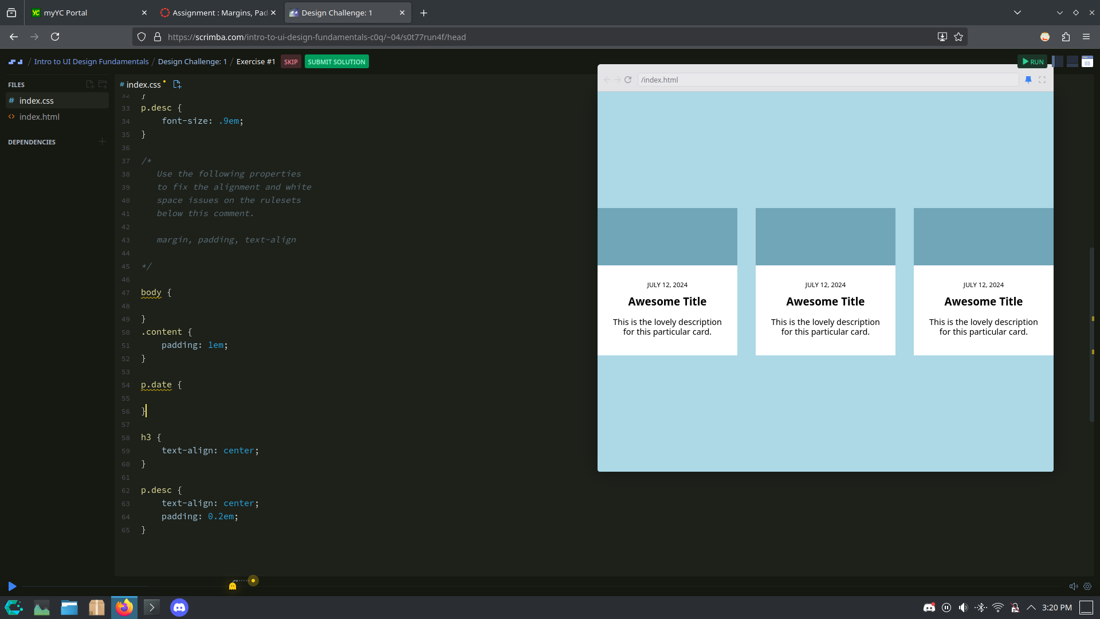
Some padding was really needed here

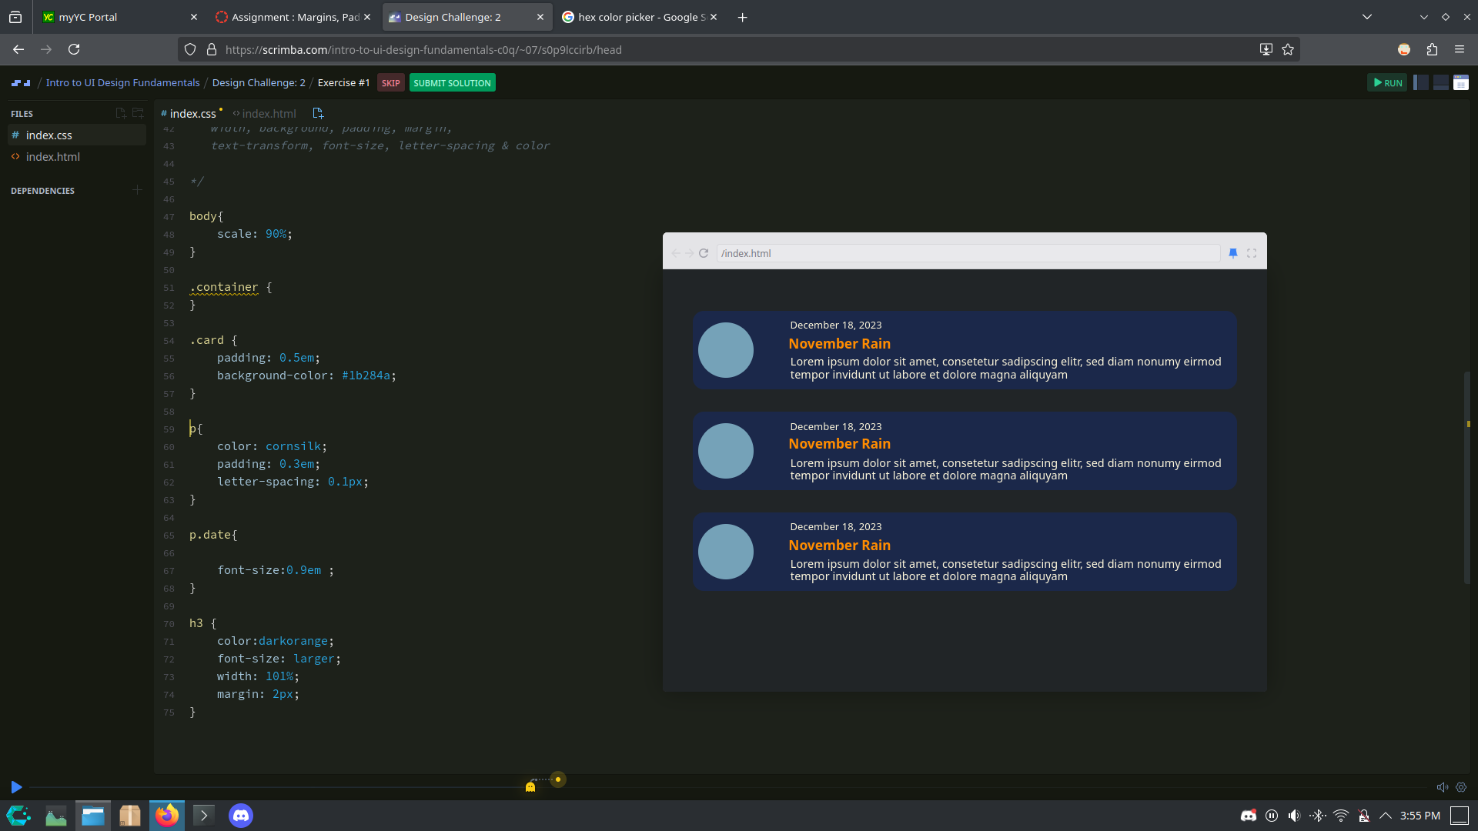
The Orange text here I think make the username pop out.

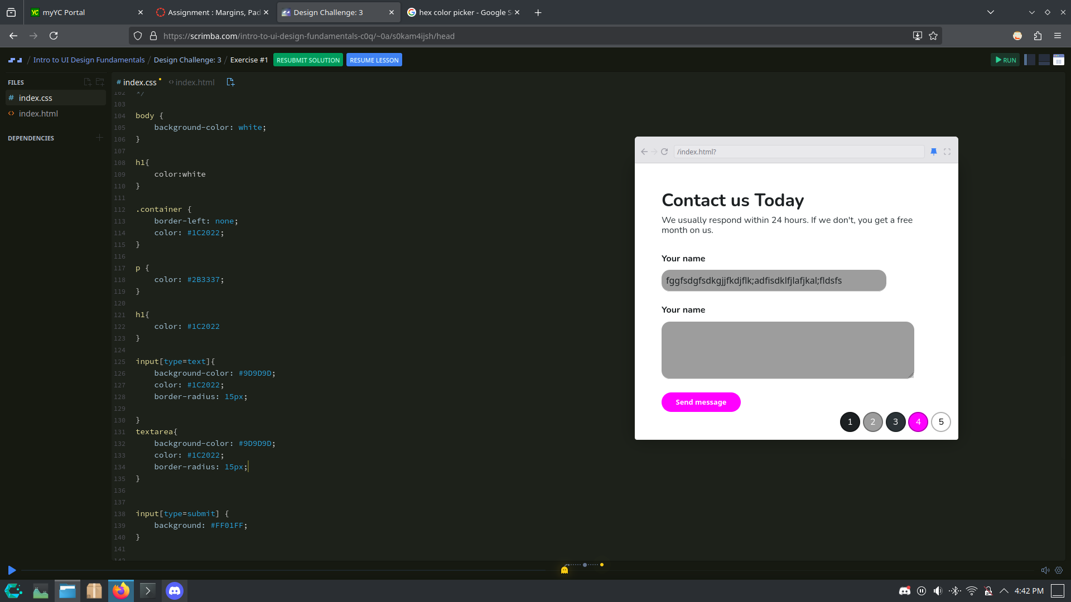
Due to a Firefox bug I had to fill in the text prompts.

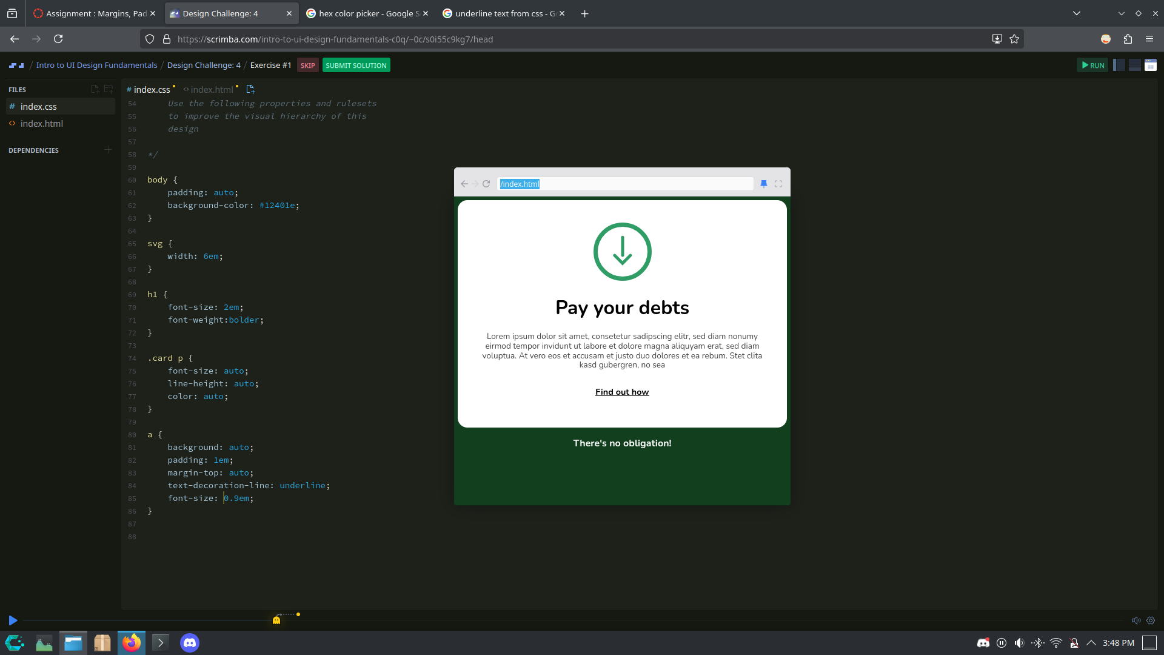
A dark green background made the white container pop out more. Underlining the link made it seem clickable.

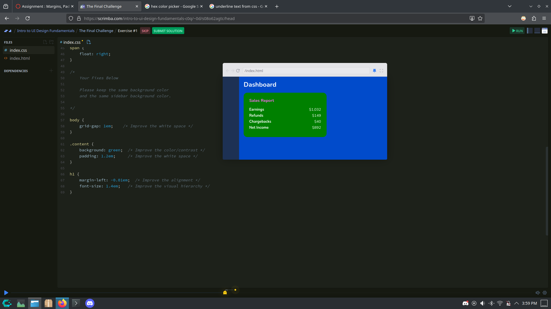

Green container to seperate it from that (ugly) blue background. Align Dashboard with the container. (I did forget that the number 0 existed)

